Year 1 home learning

We know that you will all be concerned about losing face to face learning time in school over the coming weeks. Please remember that the **most important** thing for your education is to keep **reading** and keep your **mental arithmetic** skills sharp.

Please read for at least 20 minutes a day, you can find the recommended reading list for your age group attached to this email.

**Maths**

**Numberblocks**

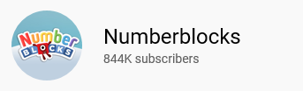<https://www.youtube.com/channel/UCPlwvN0w4qFSP1FllALB92w/playlists>

Please subscribe to the Numberblocks channel on Youtube. These are free videos which underpin the mathematics teaching we do in school.

**Number bonds to ten**

<https://www.topmarks.co.uk/maths-games/hit-the-button>

Please play Hit the Button and Select Number Bonds within ten to keep your number bonds to ten knowledge sharp.



**Reading**

Please continue to use Bug Club to read book banded texts with your children. We have set the children to be able to progress through the book bands so when they have read all the books on one stage they will be automatically have access to the next stage. We have recently sent the log in details home for you again should you have misplaced these. **Phonics**

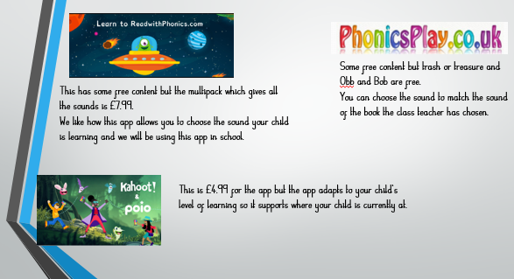To continue to support your child’s reading please access the following websites or apps to enhance your children’s phonic learning.

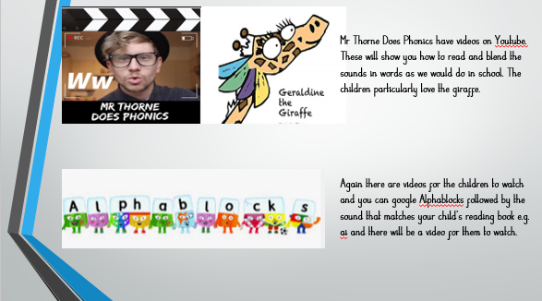

You can find lots of brilliant games, videos and quizzes to help you with your learning on the bbc bite size website. Try the spelling videos and quiz.



<https://www.bbc.co.uk/bitesize/primary>

If you are able to use a printer at home you can find school resources on twinkl.co.uk that cover every aspect of the curriculum. Parents can sign up here during the school closure to get you started:



[www.twinkl.co.uk/offer](http://www.twinkl.co.uk/offer)

Enter the code: CVDTWINKLHELPS

Above all else look after each other and keep reading! We look forward to seeing you again as soon as possible. If you require any help or support with your learning during this time please contact your teachers using the year group email address below and we will get back to you as soon as we can.

[Y1@harrisonprimaryschool.co.uk](mailto:Y1@harrisonprimaryschool.co.uk)